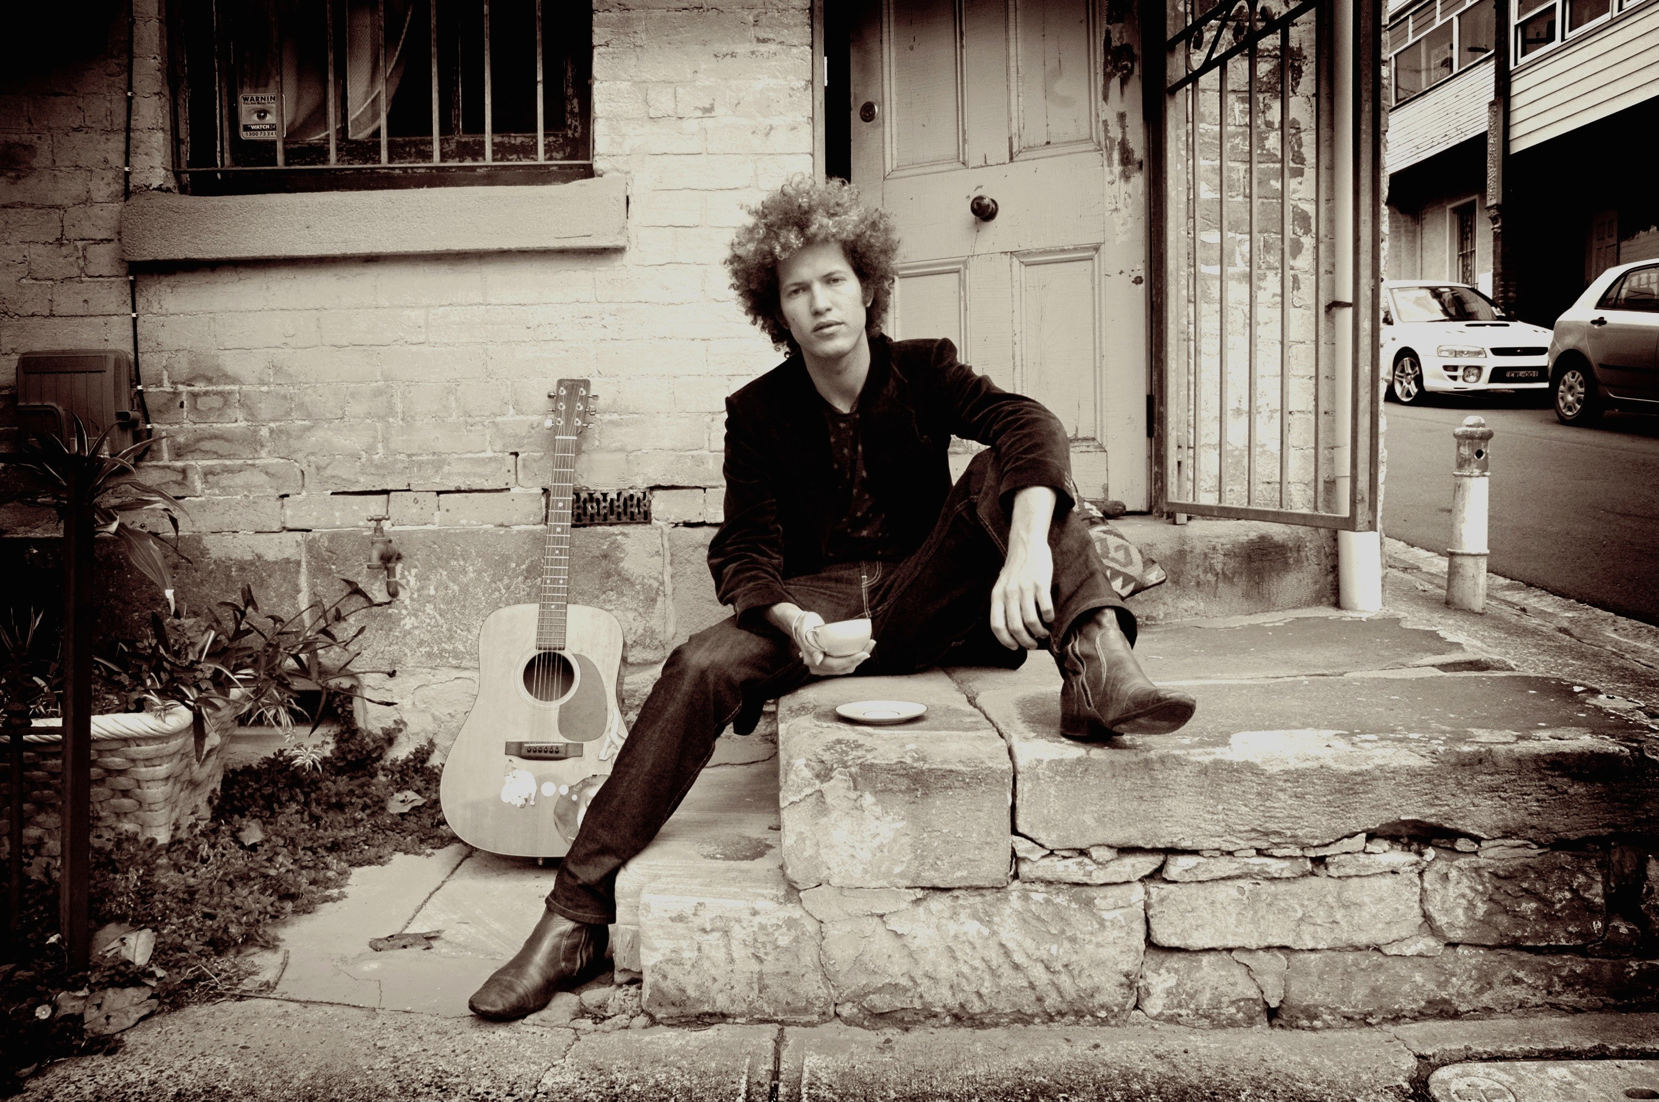
www.oldmanrivermusic.com
www.facebook.com/oldmanrivermusic
Contact: contact@oldmanrivermusic.com

Ohad Rein is the singer-songwriter, producer and multi-instrumentalist behind the internationally acclaimed OLD MAN RIVER project, an eclectic musical voyage that manages to blend conscious pop, folk-rock, psychedelia and world music, all under one warm blanket of positive, melodic and inspiring sounds.

In the past decade, Rein has been based in Sydney, Australia. In 2007 he released his debut album 'Good Morning' (SONY/BMG), which reached top chart positions in Australia, Japan and Europe. The album track 'La' reached the remarkable no. 1 position on Japanese radio airplay charts and no. 2 on the Italian radio airplay charts. The album's success led Old Man River to play countless shows around the globe. One unforgettable moment was when Old Man River appeared in Verona's Roman Colosseum in front of an audience of 20,000 people, taking part in the famous Italian FestivalBar.
Another notable moment was when Rein had the unimaginable honour to appear twice in special concerts organised in behalf and in the presence of H.H the Dalai Lama.
During this period and till this present day Old Man River has supported and cooperated with many artists and talents such as Passenger, Daniel Johnston, The Violent Femmes, Iron and Wine, The Tallest Man On Earth, Empire Of The Sun, Gomez and more.

In the lead up time to the release of the 2nd album 'Trust' (EMI), Rein went through many personal and creative changes. He became a father for the first time, ceased work with the label (SONY) that released his first album, started working with another (EMI) and signed a global publishing deal with J.Alberts & Son (AC/DC).

Rein has an ever strong fondness and connection to India, and often tends to blend Indian influences into his work. This was exemplified when the artist chose to shoot a colourful video clip for his first album track 'Sunshine', in the ancient and sacred city of Varanasi. This same affinity for the mystical subcontinent led Rein there again to record part of his second album 'Trust' in Mumbai. This phase of the recording saw him realise an old dream, working with legendary Indian producer Daman Sood (Jagjit Singh, Avida Parveen) and recording with some of Mumbai's finest Indian classical musicians.
Trust’s other behind-the-scenes talent includes producers Wayne Connolly (You Am I, Youth Group, Sarah Blasko) and Ori Avni from Israel. The Trust master tapes were flown to the USA, where Tony Hoffer (Beck, Air, Phoenix) mixed the record and tied together its many disparate strands.

Key festivals and showcases Old Man River played:
FestivalBar, Verona Italy
Summer Sonic - Tokyo, Osaka Japan
Mint Festival - Seoul, South Korea
Mosaic Music Festival - Singapore
Music Connects, Mumbai - India
In The City - Manchester, UK
South By South West - Austin, Texas, USA
Splendour in the grass - Byron Bay, Australia
Blues and roots festival - Byron Bay, Australia
One Movement, Perth, Australia
Big Sound, Brisbane, Australia
Adelaide Fringe Festival - Adelaide, Australia
Sydney Festival - Sydney, Australia

Official Video clip links:

Sunshine
http://youtu.be/MTmm_M9PlVY

La
http://youtu.be/8Q5_lYvXj-M

You're on my mind
http://youtu.be/WVugSzMpB74

Norway
http://youtu.be/9eMl2Z6jgE8

Live show links:

La - live in Verona
http://youtu.be/vQdtaxGF3V0

Sunshine - live in Seoul, Korea
http://youtu.be/MpA2fGdXdqc

Wake Up - live in Canberra
http://youtu.be/T-rIgIFlAK8

Open Up - live in Tel Aviv
http://youtu.be/r5DduhwzPGw

wedding song - live on Australian tv
http://www.youtube.com/watch?v=7mpvi30wIug

You're on my mind - Interview and live performance Adelaide
http://youtu.be/dJUlVuSHQlQ

La live in Adelaide
http://youtu.be/ayWPQ1BEgS0

Norway live in Sydney
http://youtu.be/bI4SLiQPBkY

can see full gig at ‪http://www.moshcam.com/old-man-river/metro-theatre-766.aspx

www.oldmanrivermusic.com
www.facebook.com/oldmanrivermusic
Contact: contact@oldmanrivermusic.com

